Lab 1

Initial Balance and Deposit with New Balance

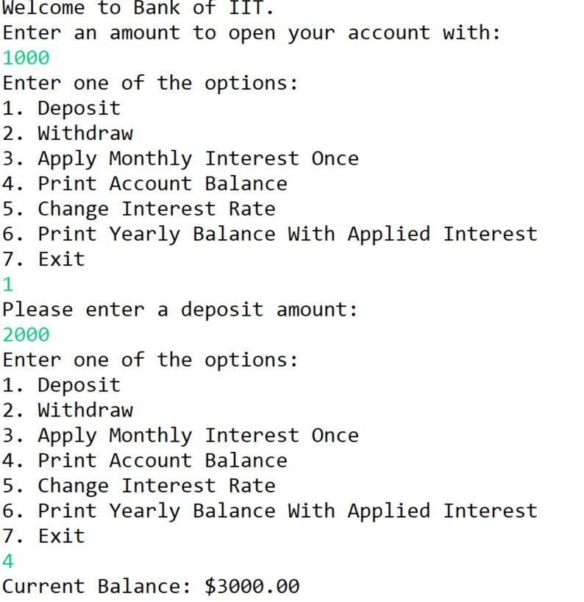

Withdrawal and Remaining Balance

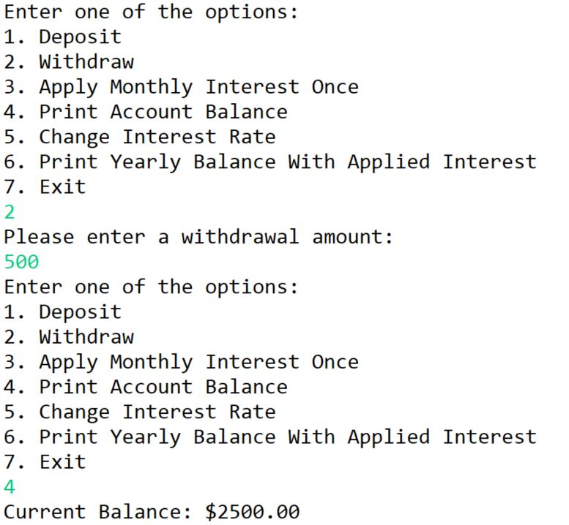

Withdrawal Below 100 With Error Message

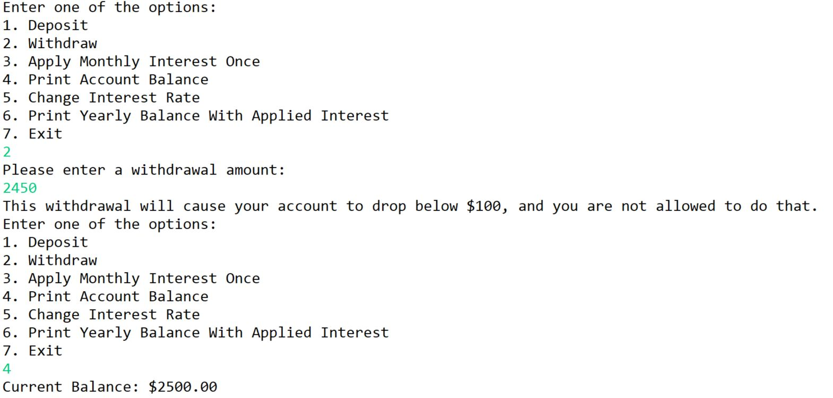

Withdrawal with $50 fee

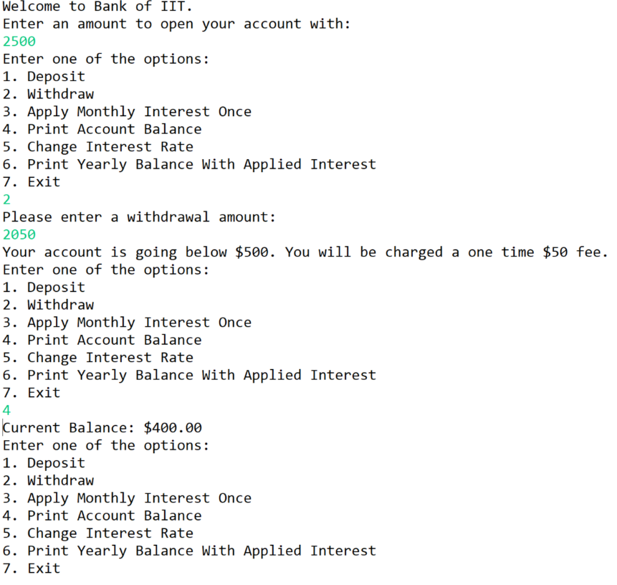

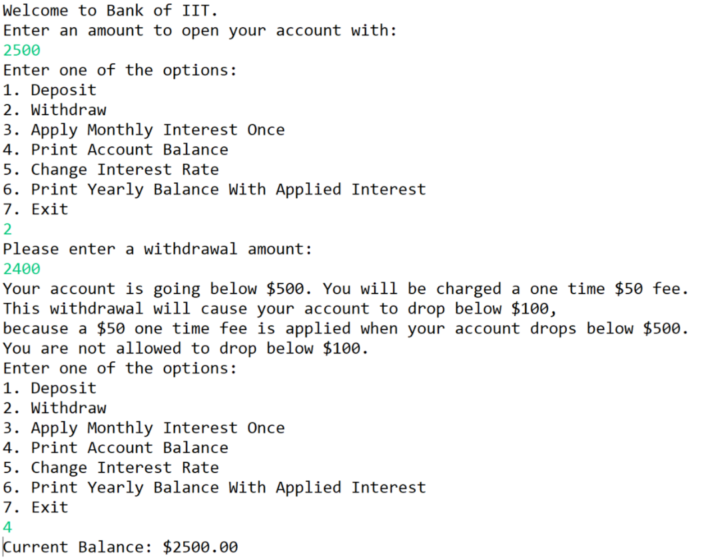$50 fee Causing to go Below $100

Yearly Balance with Interest

